**SEQUENTIAL DIAGRAM**

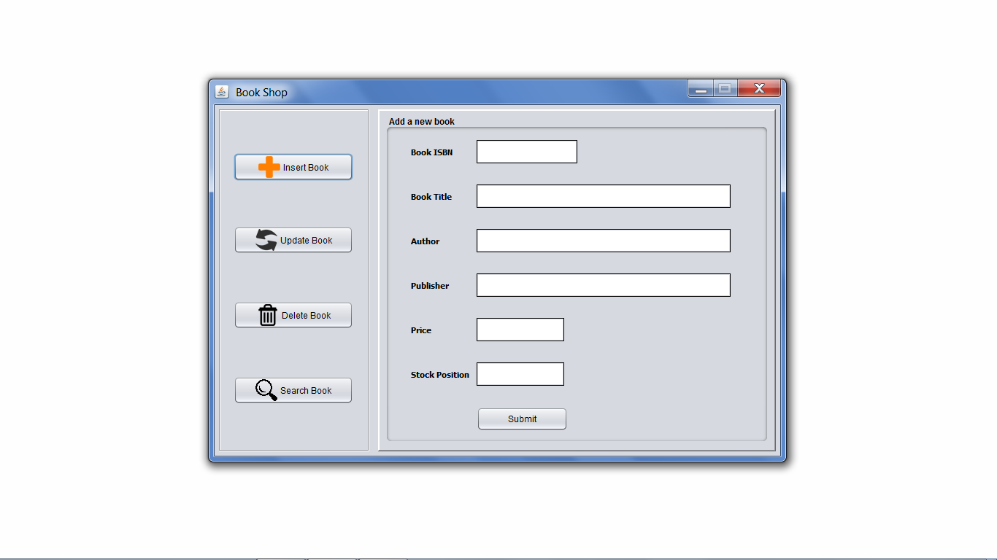

Insert Window

In above Interface, the user will input the details of the book to be added. After filling the fields and pressing the **SUBMIT** button, validation of fields will be checked. If validated successfully, Book will be added to database: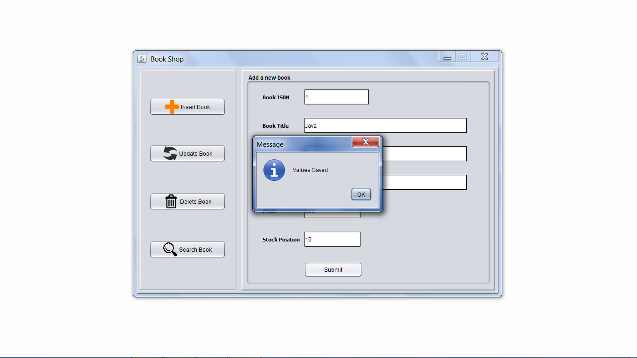

Book Inserted

If book details are found invalid, error will be appeared: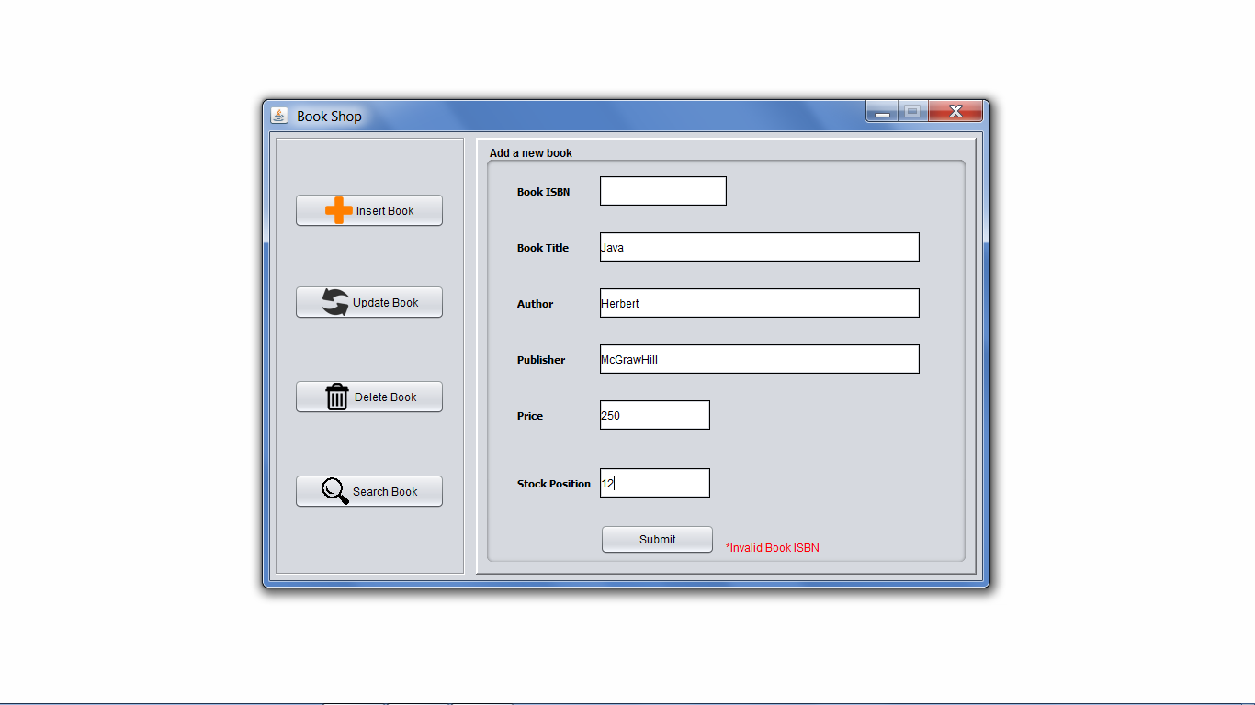

Error